PROBLEM SOLVING AND TESTING USING JAVA

NAME: V.NEELA DEVI
VTUNO: 28598
WEEK-2 PROBLEMS

- Build Array from Permutation- https://leetcode.com/problems/build-array-from-permutation/
CODE:
class Solution {
public int[] buildArray(int[] nums) {
int n = nums.length;
int[] ans = new int[n];

for (int i = 0; i < n; i++) {
ans[i] = nums[nums[i]];
}

return ans;
}
}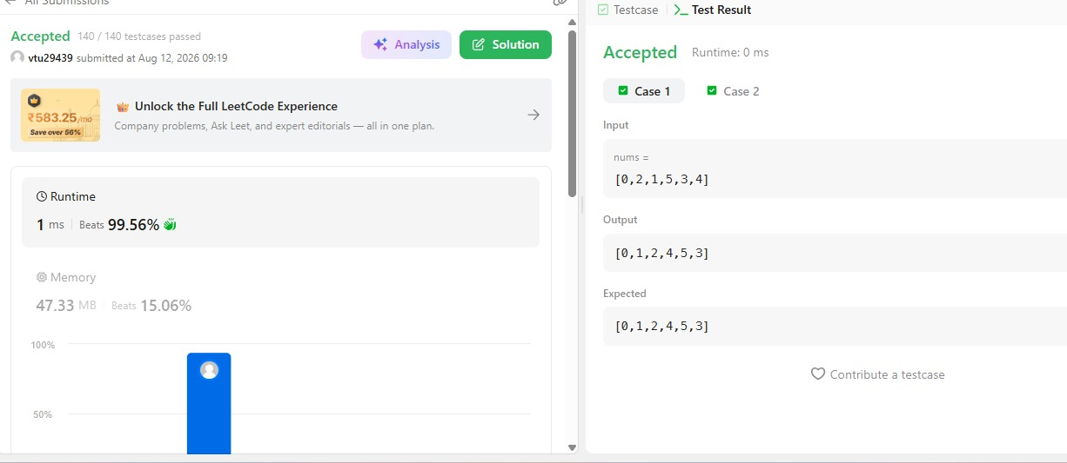

- Shuffle the Array – https://leetcode.com/problems/shuffle-the-array/
CODE:
class Solution {
public int[] shuffle(int[] nums, int n) {
int[] result = new int[2 * n];

for (int i = 0; i < n; i++) {
result[2 * i] = nums[i]; // xᵢ
result[2 * i + 1] = nums[i + n]; // yᵢ
}

return result;
}
}

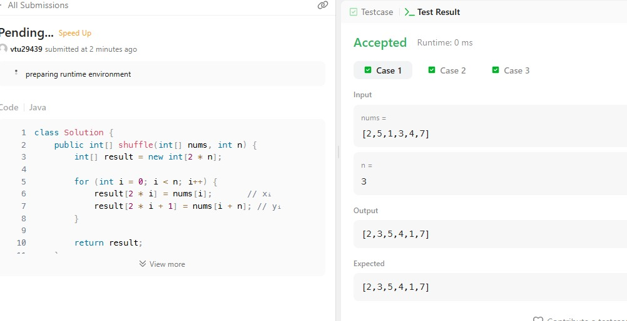

- Find the Highest Altitude – https://leetcode.com/problems/find-the-highest-altitude/
CODE:
class Solution {
public int largestAltitude(int[] gain) {
int currentAltitude = 0;
int maxAltitude = 0;

for (int g : gain) {
currentAltitude += g;
if (currentAltitude > maxAltitude) {
maxAltitude = currentAltitude;
}
}

return maxAltitude;
}
}
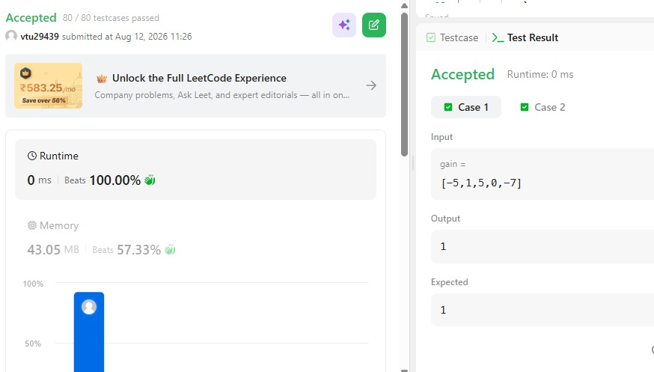
4. Java Dequeue – https://www.hackerrank.com/challenges/java-dequeue/problem
CODE:
import java.util.*;

public class test {
public static void main(String[] args) {
Scanner in = new Scanner(System.in);

if (!in.hasNextInt()) return;
int n = in.nextInt();
int m = in.nextInt();

Deque<Integer> deque = new ArrayDeque<>();
Map<Integer, Integer> countMap = new HashMap<>();

int currentUnique = 0;
int maxUnique = 0;

for (int i = 0; i < n; i++) {
int num = in.nextInt();

// Add the new element to the sliding window
deque.addLast(num);
countMap.put(num, countMap.getOrDefault(num, 0) + 1);

if (countMap.get(num) == 1) {
currentUnique++;
}

// If the window exceeds size m, remove the oldest element from the front
if (deque.size() > m) {
int removedNum = deque.removeFirst();
countMap.put(removedNum, countMap.get(removedNum) - 1);

if (countMap.get(removedNum) == 0) {
currentUnique--;
countMap.remove(removedNum);
}
}

// Once the window reaches size m, check and update maxUnique
if (deque.size() == m) {
if (currentUnique > maxUnique) {
maxUnique = currentUnique;
}
}
}

System.out.println(maxUnique);
in.close();
}
}

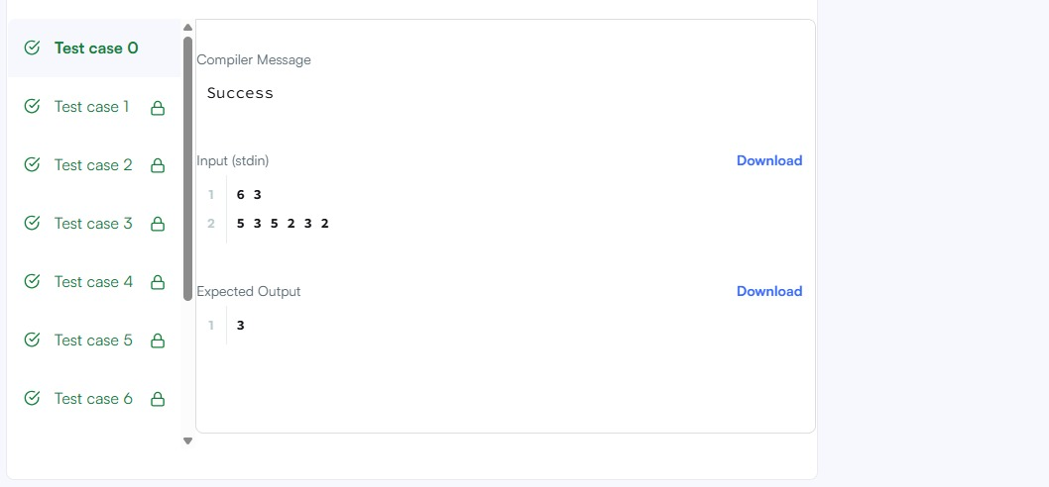

5.Java Hashset – https://www.hackerrank.com/challenges/java-hashset/problem
CODE:
import java.io.*;
import java.util.*;
import java.text.*;
import java.math.*;
import java.util.regex.*;

public class Solution {

public static void main(String[] args) {
Scanner s = new Scanner(System.in);
int t = s.nextInt();
String [] pair_left = new String[t];
String [] pair_right = new String[t];

for (int i = 0; i < t; i++) {
pair_left[i] = s.next();
pair_right[i] = s.next();
}
HashSet<String> pairs = new HashSet<String>();

for (int i = 0; i < t; i++) {
pairs.add(pair_left[i] + " " + pair_right[i]);
System.out.println(pairs.size());
}
}
}

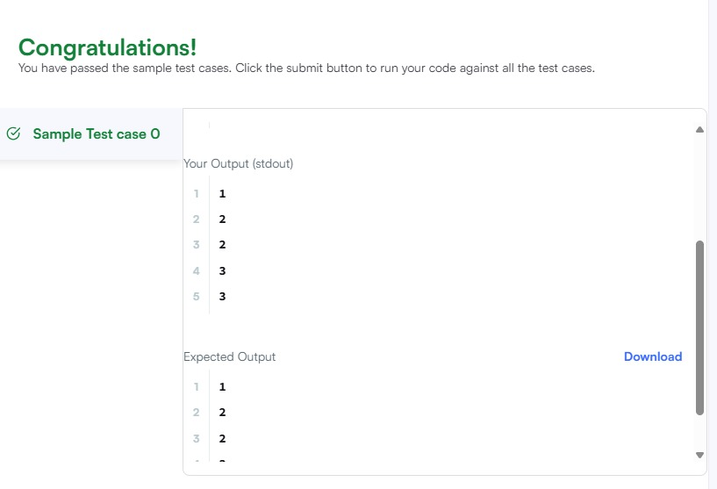

THANK YOU

